**Exercise 14: Prompting and Passing**

1. Find out what the games Zork and Adventure were. Try to find a copy and play it.

**Ya, I played it. But I don’t exactly what’s the game. I am typed something, then the reply came for my input. The values get from keyboard.**

1. Change the prompt variable to something else entirely.

**user_name = ARGV.first**

**p = ">>>"**

**puts "Hi #{user_name}."**

**puts "I'd like to you ask some questions."**

**puts "Do you like me #{user_name}?"**

**puts p**

**likes = $stdin.gets.chomp**

**puts "Where do you live in #{user_name}", p**

**lives = $stdin.gets.chomp**

**puts "What kind of computer do you have?", p**

**computer =$stdin.gets.chomp**

**puts """**

**Alright, so you said #{likes} about liking me.**

**You live in #{lives}. Not sure where that is.**

**And you have a #{computer} computer. Nice. """**

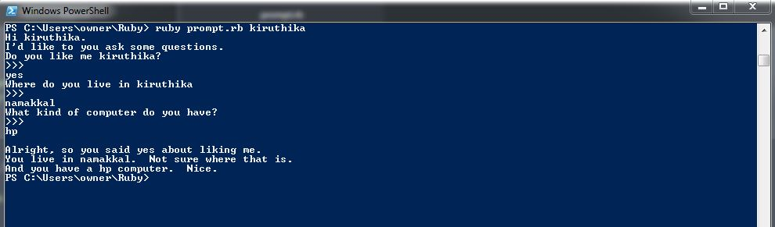

1. Add another argument and use it in your script, the same way you did in the previous exercise with first, second = ARGV.

**user_name, age = ARGV**

**p = ">>>"**

**puts "Hi #{user_name}."**

**puts "I'd like to you ask some questions."**

**puts "Do you like me #{user_name}?"**

**puts p**

**likes = $stdin.gets.chomp**

**puts "Where do you live in #{user_name}", p**

**lives = $stdin.gets.chomp**

**puts "What kind of computer do you have?", p**

**computer =$stdin.gets.chomp**

**puts """**

**Alright, so you said #{likes} about liking me.**

**You live in #{lives}. You're #{age} years old.**

**And you have a #{computer} computer. Nice. """**

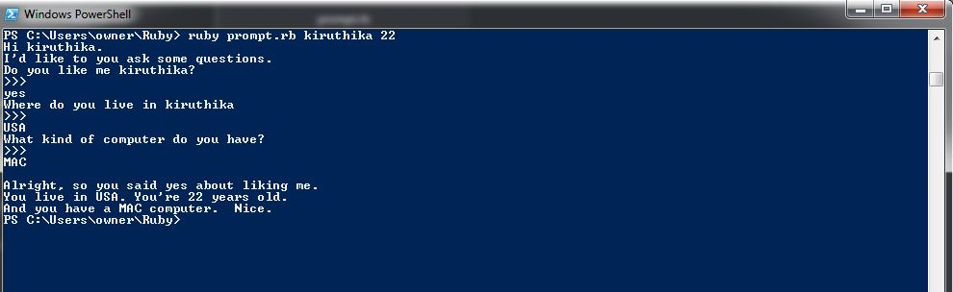

1. Make sure you understand how I combined a """ style multiline string with the #{} format activator as the last print.

**I understand.**